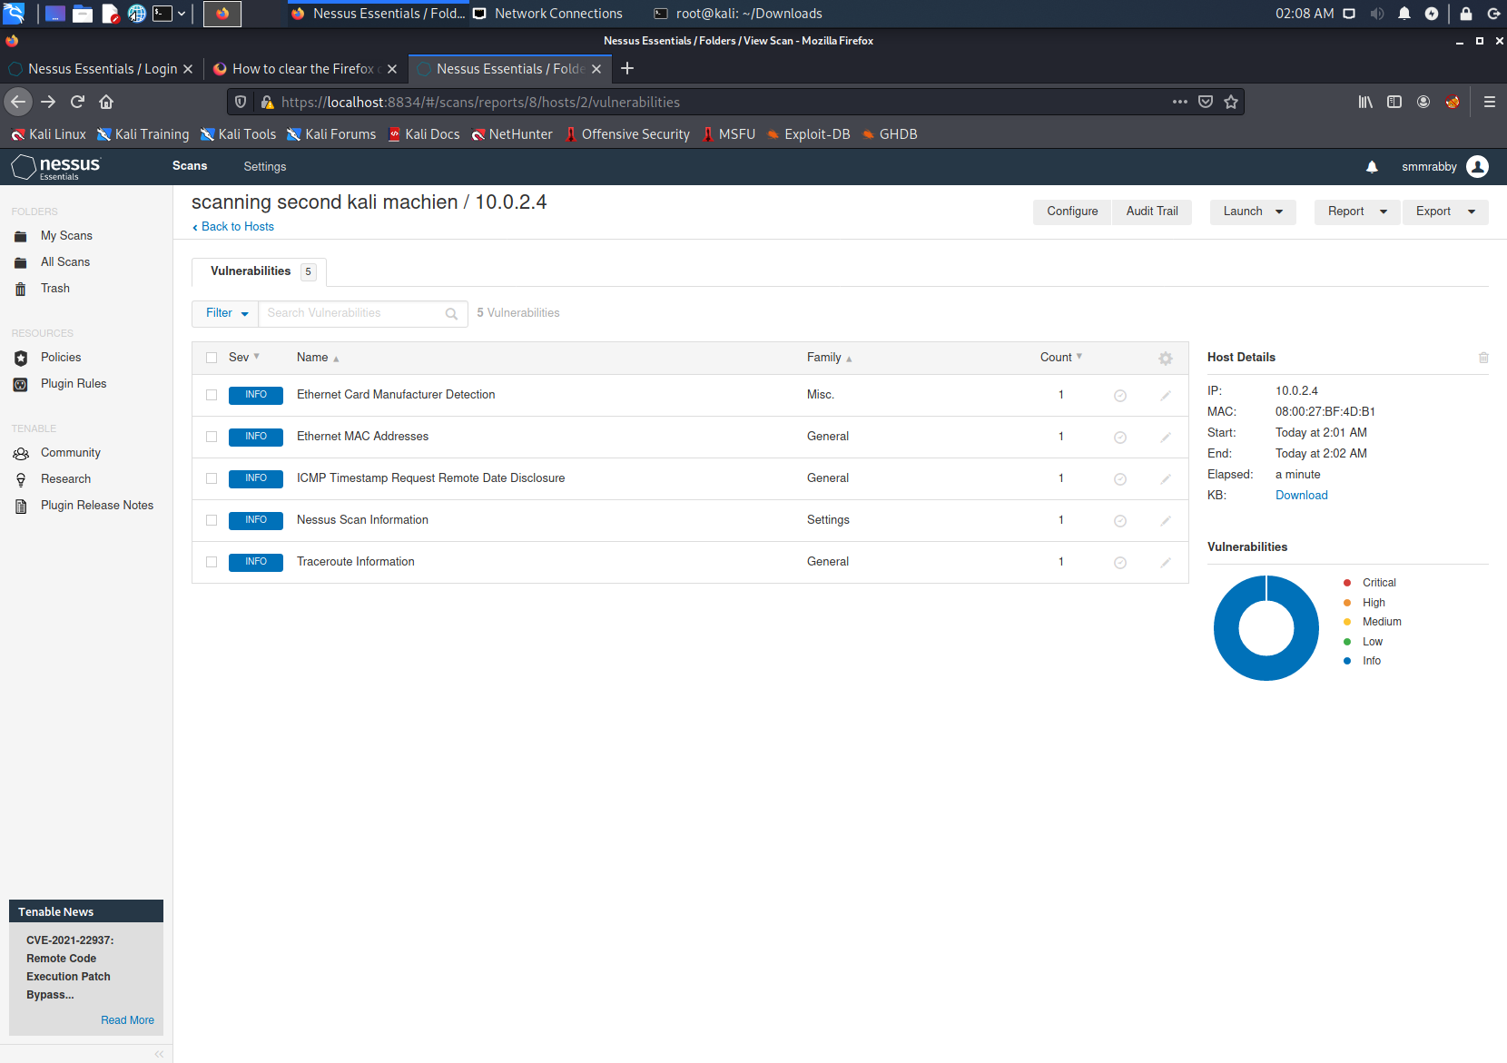

Abstract:- A second virtual machine(kali 19.1) was scanned by Nessus.

Report:- No vulnerability was detected. Though, Nessus indicated 3 informational disclosures. None of them were critical. Each of the disclosed below.

1. Nessus detected the ethernet card manufacturer through the MAC address. And the domain holder was listed as “PCS Systemtechnik GmbH”. Which really belongs to the Virtual box.
2. Nessus directed MAC Address, which is basically the same as the first one.
3. The target machine responded to an ICMP echo reply, which is same as pinging the machine.